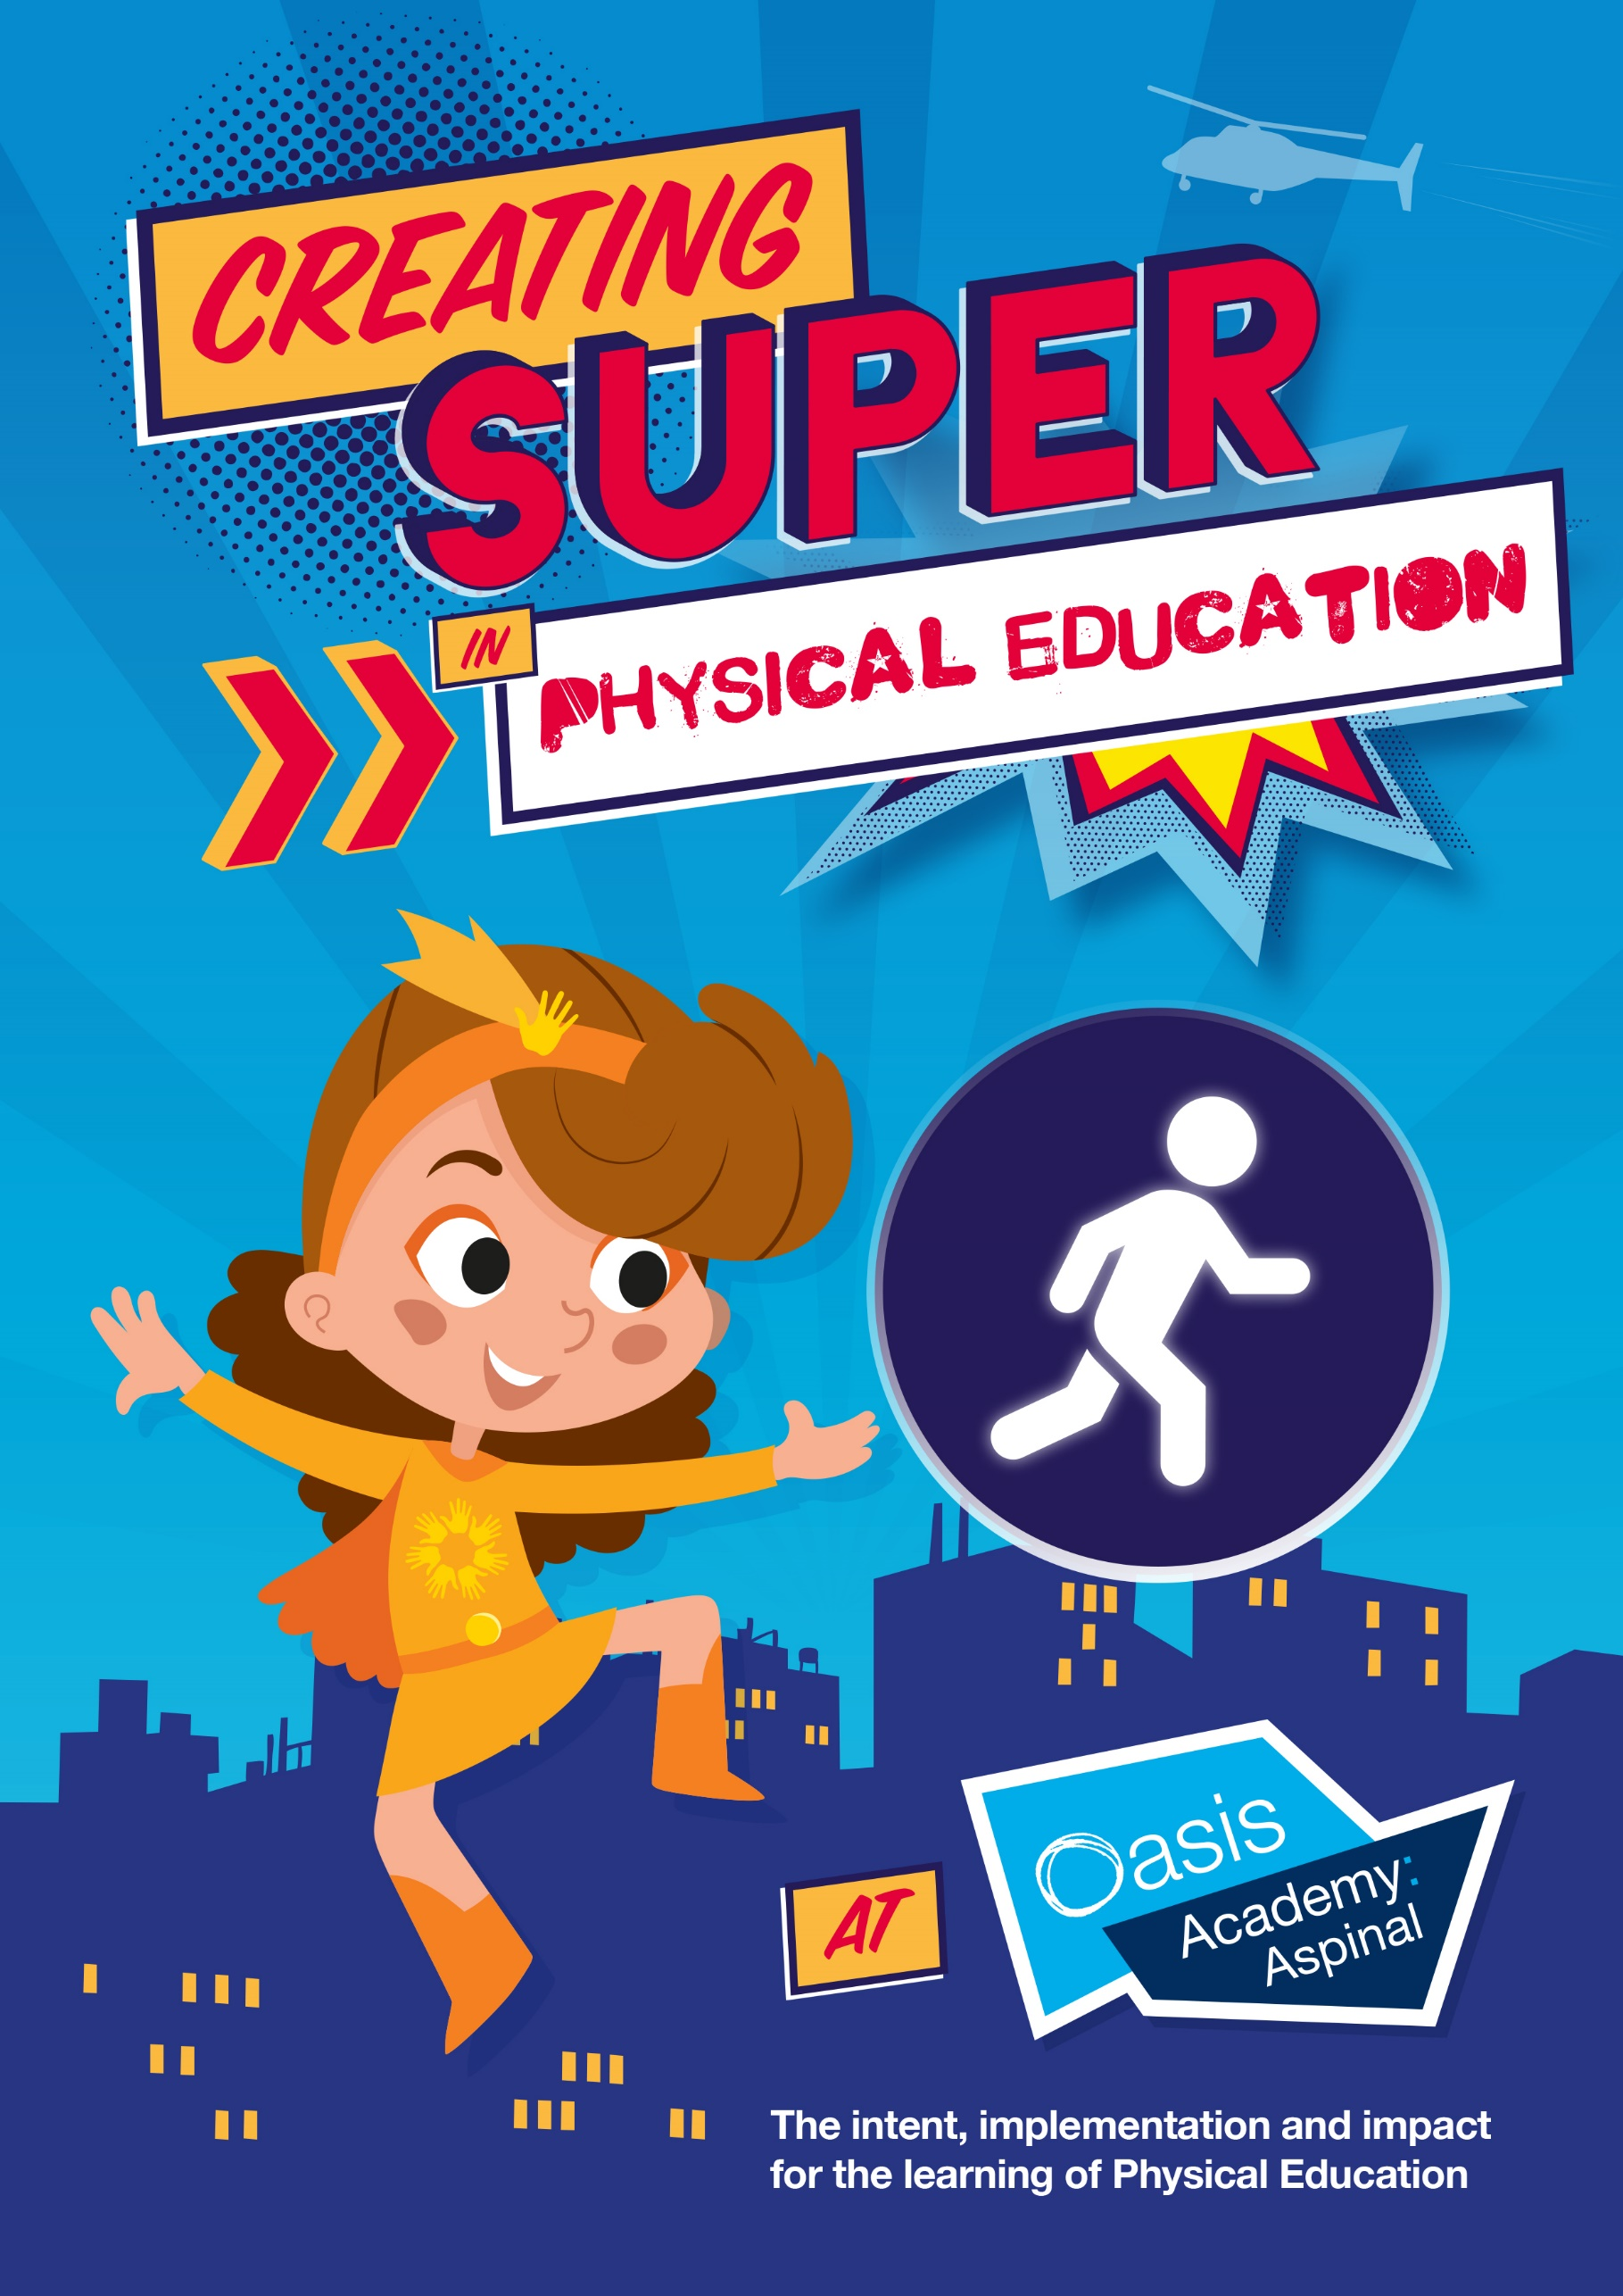

Why is PE important at Aspinal?
- Children will have the opportunity to be physically active for sustained periods of time
- Children will be able to concentrate for sustained periods of time as they have been given the opportunity to release energy through planned physical activity
- Children will become more physically literate and move confidently and with control in a wide range of physical activities.
- PE gives children information that helps shape a brighter and safer future by keeping children healthy and teaching them healthy habits
- Children will have the opportunity to play in team sports and work in unison. Understanding that it is not about winning and losing, but about working collaboratively
- PE allows the opportunity for children to feel part of an inclusive environment
- By the end of Year 4, children learn how to swim and gain an understanding of the importance of water safety

What are the key knowledge concepts in PE at Aspinal?
Competitive | Skills | Knowledge
Range of sports e.g. football, hockey, cricket, netball, rounders etc | Control  Flexibility  Agility  Balance  Coordination  Patterns  Problem solving  Communicating  Technique | Evaluating  Comparing  Tactics  Safety  Reflecting  Analysing
Movement | Teamwork
Running  Throwing  Jumping  Catching  Roll  Sequences | Defending  Attacking  Collaboration  Planning

What are the key PE subject discipline skills?
- Develop fundamental movement skills, becoming increasingly competent and confident and access a broad range of opportunities to extend their agility, balance and coordination
- Children can engage in competitive and cooperative physical activities in increasingly challenging situations
- Children will master basic movements including running, jumping, throwing and catching, as well as developing balance, agility and coordination
- Children can participate in team games, developing simple tactics for attacking and defending
- Children can perform dances using simple movement patterns
- Children will enjoy communicating, collaborating and competing with each other
- Children will develop an understanding of how to improve in different physical activities and sports
- Children will learn how to evaluate and recognise their own success
- Children will develop flexibility, strength, technique, control and balance
- Children will take part in outdoor and adventurous activity challenges
- Children will be able to swim competently, confidently and proficiently over a distance of at least 25 metres

How does Aspinal ensure progression in our key knowledge and concepts in PE?
- Curriculum identifies points where comparisons can be made
- Key concepts are revisited to consolidate pupils understanding
- Knowledge taught builds on prior learning and is therefore more in-depth
- Increasing complexity of skills and movement and precision is expected
- Children are able to evaluate and improve their performance with more precision
- Children are physically confident in a way that supports their health and fitness
- Children are able to take part in physically demanding activities
- Children will develop a range of skills across a variety of games and activities which will build character and embed values such as fairness and respect

How do we know our children have made progress?
End points FS
Children can
- Show good control and co-ordination in large and small movements.
- They move confidently in a range of ways, safely negotiating space.
- They handle equipment and tools effectively, including pencils for writing.
- Explain why safety is an important factor in handling tools, equipment and materials, and have sensible rules for everybody to follow.
- Understand the importance for good health of physical exercise, and a healthy diet, and talk about ways to keep healthy and safe
- Manage their own basic hygiene and personal needs successfully, including dressing and going to the toilet independently.

End points KS1
Children can
- Master basic movements including running, jumping, throwing and catching
- Develop balance, agility and coordination and begin to apply these in a range of activities
- Participate in team games, developing simple tactics for attacking and defending
- Perform dances using simple movement patterns
- Build character and embed values such as fairness and respect

End points KS2
Children can
- Use running, jumping, throwing and catching in isolation and in combination
- Play competitive games, modified where appropriate (for example badminton, basketball, cricket, hockey, netball, rounders, tennis) and apply basic principles suitable for attacking and defending
- Develop their flexibility, strength, technique, control and balance
- Perform dances using a range of movement patterns
- Take part in outdoor and adventurous activity challenges both individually and in a team
- Compare their performances with previous ones and demonstrate improvement to achieve their personal best
- Swim competently, confidently and proficiently over a distance of at least 25m
- Use a range of strokes effectively, perform safe, self-rescue in different water based situations

 | Year 1 | Year 2 | Year 3 | Year 4 | Year 5 | Year 6
Autumn 1 | Dance – Animals  Movement Skills 1 | Dance – Fire of London  Movement Skills 2 | Dance – Dance Around the World  Hockey | Dance – Romans  Hockey | Dance – British Values  Lacrosse | Dance – British Values  Lacrosse
Autumn 2 | Invasion Game Skills 1  Gymnastics- Balancing and Spinning on Points and Patches | Invasion Games Skills 2  Gymnastics – Pathways: straight, zipping and curving | Gymnastics – Linking movements together  Basketball | Basketball  Swimming | Gymnastics – Matching, mirroring and contrast  Netball | Gymnastics – Counter balance and counter tension  Netball
Spring 1 | Dance – Mini Beasts  Movement Skills 2 | Dance – Mini Beasts  Movement Skills 3 | Dance – Egyptians  Tag Rugby | Gymnastics – Arching and bridging  Tag Rugby | Dance – Dance through the ages  Handball | Dance – World War 2  Handball
Spring 2 | Net and Wall Game  Skills 1  Gymnastics – Pathways – small and long | Net and Wall Game  Skills 2  Gymnastics – Spinning, turning and twisting | Gymnastics – Receiving body weight  Football | Football  Swimming | Gymnastics – Partner work – under and over  Football | Gymnastics – Flight  Flag football
Summer 1 | Dance – Fire of London  Striking and Fielding Games Skills 1 | Dance – Under the Sea  Striking and Field Game Skills 2 | Dance - Space  Rounders | Dance – Space  Rounders | Dance – The Haka  Cricket | Dance – The Victorians  Cricket
Summer 2 | Athletics 2  Gymnastics – Wide, narrow, curled rolling and balancing | Athletics  Gymnastics – Stretching, curling and arching | Athletics  Gymnastics – Symmetry and asymmetry (partners) | Athletics  Swimming | Athletics  Gymnastics – Synchronisation and canon | Athletics  Gymnastics – Group Sequencing
Medium Term Plans
Year 1
Year 2
Year 3
Year 4

Year 5
Year 6

